**DAILY ONLINE ACTIVITIES SUMMARY**

|  |  |  |  |  |  |  |  |  |
| --- | --- | --- | --- | --- | --- | --- | --- | --- |
| **Date:** | **26/6/2020** | | | | | **Name:** | **Nivedita** | |
| **Sem & Sec** | **4th sem/ A-sec** | | | | | **USN:** | **4al18cs053** | |
| **Online Test Summary** | | | | | | | | |
| **Subject** | | **-----** | | | | | | |
| **Max. Marks** | | **30** | | **Score** | | | **---** | |
| **Certification Course Summary** | | | | | | | | |
| **Course** | **IOS 10 developer** | | | | | | | |
| **Certificate Provider** | | | **udemy** | | **Duration** | | | **49 hours** |
| **Coding Challenges** | | | | | | | | |
| **Problem Statement:** **Given start and end of a range, write a Python program to print all negative numbers in given range.** | | | | | | | | |
| **Status: done** | | | | | | | | |
| **Uploaded the report in Github** | | | | | **yes** | | | |
| **If yes Repository name** | | | | | [**https://github.com/nivi-nivedita/lockdown-coding-program/blob/master/python%20program%20(print%20all%20negative).txt**](https://github.com/nivi-nivedita/lockdown-coding-program/blob/master/python%20program%20(print%20all%20negative).txt) | | | |
| **Uploaded the report in slack** | | | | | **yes** | | | |

Certification Course Details: I end machine learning course, because it doesn’t contain certificate and I started new course is IOS 10 developer in udemy.

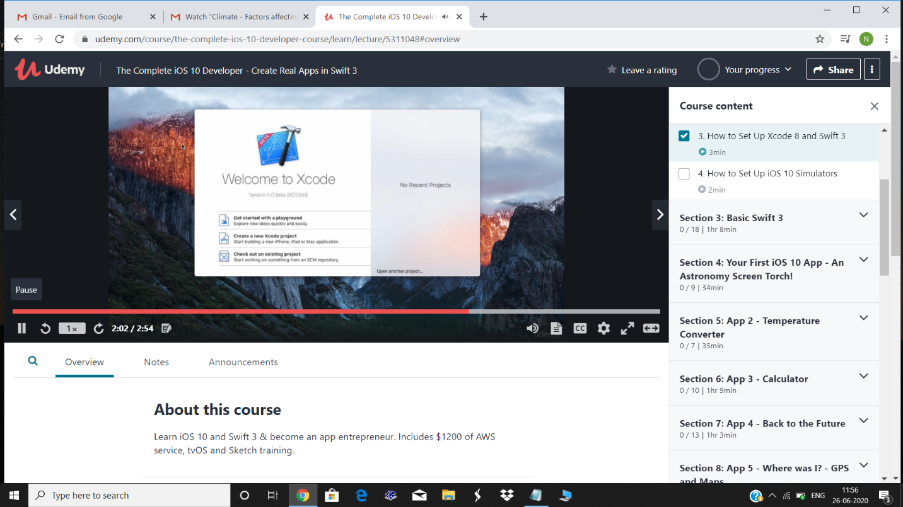

Today I attended webinar on cyber security which is conducted by HOD sir (Manjunath kothari);

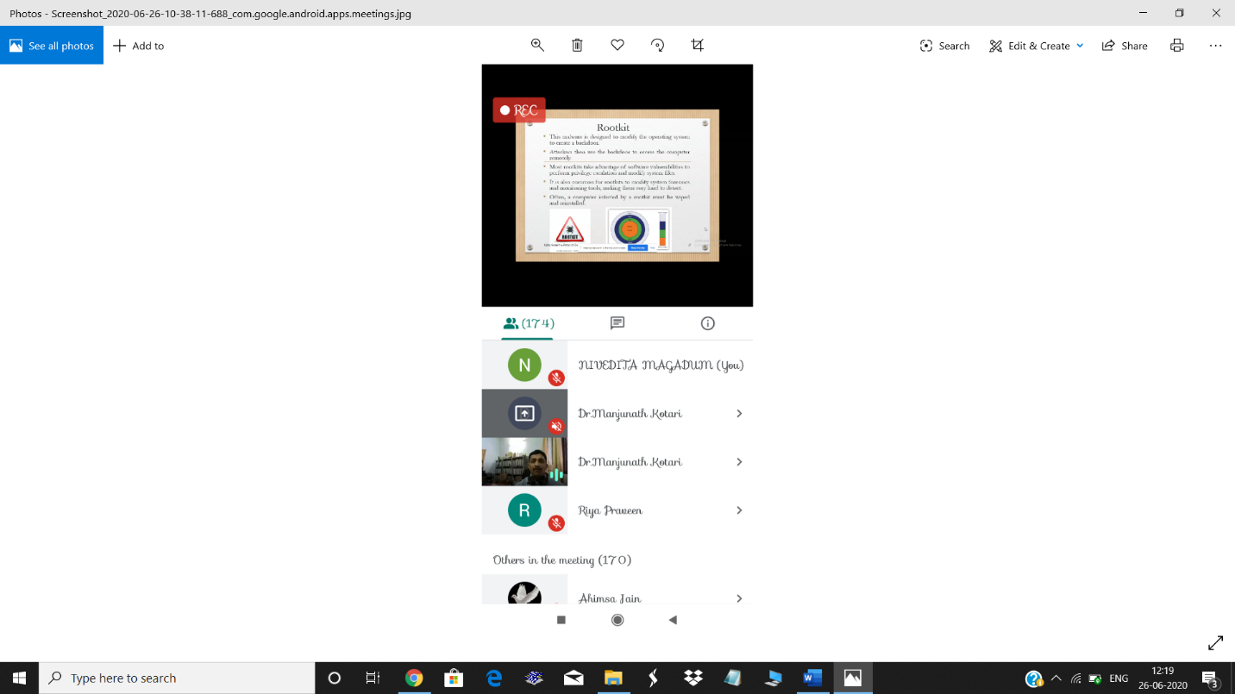

Coding Challenges Details: Given start and end of a range, write a Python program to print all negative numbers in given range.

Executed and uploaded.

